LOCAL AREA HEALTH AND WELLBEING PARTNERSHIP

TERMS OF REFERENCE

Introduction

Health and Wellbeing Boards are a key element of the Health and Social Care Act 2012 and they are a means to deliver improved strategic co-ordination across the NHS, social care, children’s services and public health. The Boards must assess the needs and assets of the local population, producing a strategy that addresses these needs and builds on any assets, influences commissioning plans of organisations and promotes joint commissioning and integrated provision. Statutory responsibility for the provision of health and wellbeing boards sit with upper tier authorities, which for Lancashire is Blackburn with Darwen Borough Council, Blackpool Borough Council and Lancashire County Council. For the purposes of this terms of reference the three upper tier authorities with statutory responsibility for health and wellbeing will be referred to as the three statutory health and wellbeing authorities.

The health and wellbeing “system” is changing at both a pan-Lancashire level and at a local delivery level, in line with the Five Year Forward View for the NHS, national Sustainability and Transformation Plan (STP) agenda and the Combined Authority approach for Lancashire.

In light of these changes, the Leaders and Chief Executives from each of the Lancashire local authorities have worked together to design a new model for health and wellbeing board governance for the pan-Lancashire footprint. The model reflects a need to ensure robust accountability of system changes linked to the Lancashire and South Cumbria STP delivery and service reconfigurations and as such aligns itself to the delivery footprints for the STP. The agreed model, presented in Figure 1 below, takes the form of a single Health and Wellbeing Board for the pan-Lancashire footprint, with five local area health and wellbeing partnerships (LHWBPs), reflecting the local health economies.

The model has been designed to provide the strongest collective influence and governance across the new emerging health and wellbeing system.
Figure 1.

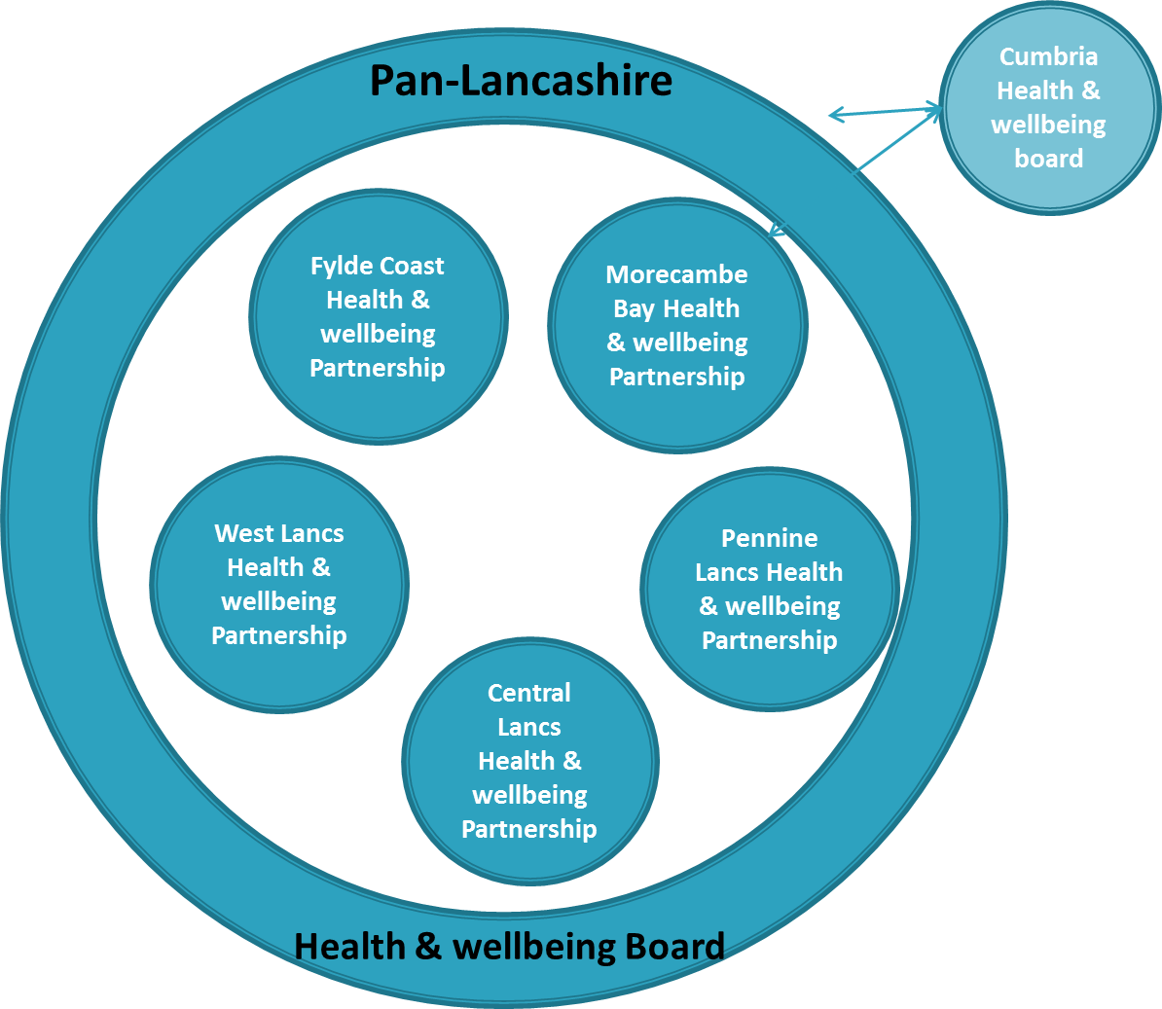

Local Area Health and Wellbeing Partnership
Terms of Reference

- Aims

  - To improve life chances for the residents of <INSERT AREA> by improving health and wellbeing, creating healthy places and reducing health inequalities, giving all people the opportunity to Start Well, Live Well and Age Well;

  - To provide local accountability for improved health and wellbeing (morbidity, mortality, quality of life) and health equity outcomes for the population of Lancashire;

  - To promote integration and partnership working between the NHS, social care, public health and other local services.

- Purpose

  - To support the pan-Lancashire Health and Wellbeing Board in its preparation of a Joint Strategic Needs Assessment (JSNA) and Joint Health and Wellbeing Strategy (JHWS);

  - To ensure the implementation of the pan-Lancashire Joint Health and Wellbeing Strategy within their local delivery area and the achievement of associated outcomes;

  - To approve plans for joint commissioning and pooled budget arrangements relevant to their local delivery area, so people are provided with better integrated care and support;

  - To make recommendations to the pan-Lancashire Health and Wellbeing Board in respect of the local area CCG commissioning intentions and plans for joint commissioning and pooled budget arrangements relevant to their local delivery area;

  - To oversee the implementation of plans for joint commissioning and pooled budget arrangements, within their local delivery area

  - To lead close working between commissioners and providers of health and social care services and other health related services within <INSERT AREA>, such as housing and other local government services, across Lancashire and other relevant footprints;

  - To influence the development of major plans and service redesigns of health and wellbeing related services both within their local delivery area and at the pan-Lancashire level, to ensure that local needs are understood and reflected within proposals.

NB arrangements in relation to the development and approval of Better Care Fund plans will be defined during 2017, when the future direction of travel of the Fund both from a national Government point of view and a Lancashire and South Cumbria STP point of view is known and understood.

- Accountability

  - The Partnership will be accountable to the pan-Lancashire Health and Wellbeing Board; the relevant local Council and Clinical Commissioning Group governing bodies, by ensuring access to meeting minutes and presenting papers as required;

  - The local area Clinical Commissioning Groups will report to the Partnership on a regular basis, by ensuring access to meeting minutes and presenting papers as required;

- Leadership

  - Leadership of the Partnership is as follows:

- Chair – a councillor
- Vice-chair – a CCG representative

- Membership

  - Core membership:

- A representative from each district level council relevant to the area
- A representative from each CCG relevant to the area
- A representative from Lancashire County Council
- The relevant Divisional Commander of Lancashire Constabulary
- The relevant Chief Officer of Lancashire Fire and Rescue Service
- One or more VCFS representatives
- A Healthwatch representative
- Children’s services; adult services and public health departmental representatives
- <For the Morecambe Bay area only - A representative from the relevant HWBB for Cumbria>

  - Provider representatives relevant to the local area will also be invited to form part of the Partnership, however, these members will not have voting rights;

  - The co-option of other members, including any lay members, will be at the discretion of the Partnership;

  - Named deputies for Partnership members are as follows;

- To be agreed

  - The Chair and Vice Chair will keep under review the membership of the Board and if appropriate will make recommendations on any changes to the core membership as required, to continue to respond to changes in the system.

- Voting members

6.1 The core members outlined above, or their nominated deputies, will be the only individuals with voting rights.

- Invited members

7.1 Additional members may be invited at the discretion of the Partnership to specific meetings. These are likely to include:

- Representatives from the NHS Commissioning Board
- Local authority directors or heads of service
- Other officers of the local authorities, NHS and other local health and wellbeing stakeholders
- Other councillors of the local authorities.

7.2 Invited members will not have voting rights.

- Decision making

  - The Partnership will need at least a third of its membership <INSERT EXACT NUMBER RELEVANT TO AREA> to be quorate – this must include one member from each of the relevant local authorities and one Clinical Commissioning Group member. Voting members will appoint deputies with the agreement of the Chair;

  - Where consensus cannot be reached the matter will be decided by a simple majority of those voting members present in the room at the time the question was put. The Chair will take the vote by a show of hands. If there are an equal number of votes for and against, the Chair will have a second or casting vote.

- Roles and responsibilities of Partnership members

  - To work together effectively to support the production and delivery of the Joint Strategic Needs Assessment and Joint Health and Wellbeing Strategy;

  - To work within the Partnership to build a collaborative partnership to key decision making that embeds health and wellbeing challenge, issue resolution and provides strategic system leadership;

  - To participate in Partnership discussions to reflect the views of their organisations, being sufficiently briefed to be able to make recommendations about future policy developments and service delivery;

  - To champion the work of the Partnership in their wider work and networks and in all individual community engagement activities;

  - To share any changes to strategy, system configuration and performance pertinent to their own partner organisations, with the Partnership, outlining the consequences of such on budgets and service delivery, to allow the Partnership to consider the wider system implications;

  - To ensure that there are communication mechanisms in place within their organisations to enable information about the Partnership’s priorities and recommendations to be effectively disseminated;

- Agenda setting and notice of meetings

  - The agenda will be developed by partnership representation at agenda setting meetings and membership of this group is, as a minimum, Chair and Vice-chair.

  - Any agenda items or reports to be considered at the meeting should be submitted to the nominated Council’s Democratic Services no later than seven working days in advance of the next meeting. No business will be conducted that is not on the agenda, unless agreed with the Chair prior to commencement of the meeting.

- Procedure at meetings

  - Meetings of the Board are not required to be open to the public

  - The Partnership may also hold development / informal sessions throughout the year where all members are expected to attend and partake as the agenda suggests.

- Conflict of interest

  - In accordance with the Combined Authority’s Committee Procedure Rules, at the commencement of all meetings all Board members shall declare disclosable pecuniary or non-pecuniary interests and any conflicts of interest;

  - In the case of non-pecuniary matters members may remain for all of part of the meeting, participate and vote at the meeting on the item in question;

  - In the case of pecuniary matters members must leave the meeting during consideration of that item.

- Code of conduct

  - All Councillors and co-opted members of Council committees are required to comply with the Code of Conduct of the Combined Authority <insert relevant section when finalised> Therefore, all voting members of the Board will be required to comply with the Code of Conduct.

  - Sections of the Combined Authority Code of Conduct, relevant to declarations of interest to be inserted once finalised.

  - The NHS Commissioning Board (NHS England) is under a duty to issue guidance to CCGs on the exercise of their functions in relation to conflicts of interest and CCGs must have regards to such guidance. This list is not exhaustive – as non-Councillor members of Board may also be bound by other codes of conduct and professional standards. It should also be noted that the public law notions of predetermination and bias will also apply.

  - As a matter of process, each agenda of the Health and Wellbeing Board will have “Declarations of Interest” as a standing item.
- Governance

  - The Health and Wellbeing Partnership is a sub-committee of the pan-Lancashire Health and Wellbeing Board, which in-turn is a committee of the statutory HWB councils established in accordance with section 102 LGA 1972. Reports before the Board requiring decision will have gone through necessary governance of the author / owner as applicable. Reports will also be clear what and to whom the recommendations apply. A full copy of the Local Authority (Public Health, Health and Wellbeing Boards and Health Scrutiny) Regulations 2013 (SI 2013/218) is available on request.

